Name______________ IPad#__________
Topic # 3
Periodic Table
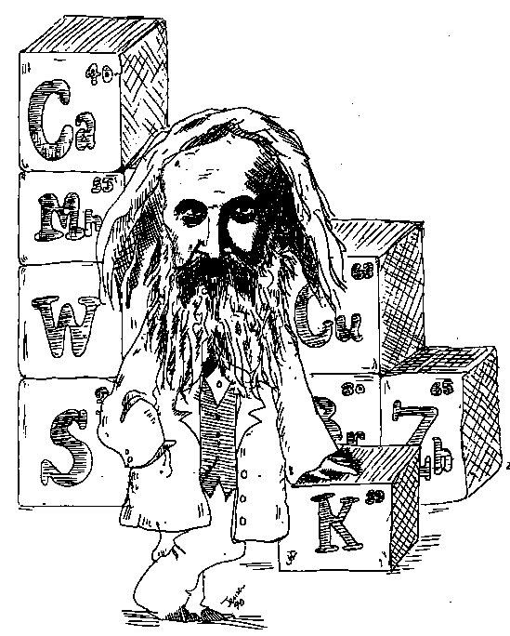

Textbook Chapter 6

Homework Packet Due:___________________

Exam Dates: Free Response: _______________________
Multiple Choice:_______________________

Periodic Table Outline and Student Outline

- The Periodic Law
Periodic Law states that the properties of the elements are periodic functions of their atomic numbers. In other words, when the elements are arranged in order of increasing atomic number, the properties of the elements repeat regularly.

- Organization of the Periodic Table (use your periodic table)
horizontal rows called periods are numbered 1 to 7; elements in the same period have the same number of principle energy levels (PEL’s) or shells

vertical columns called groups or families, are numbered 1 to 18; elements in the same group have the same number of valence electrons and therefore have similar chemical properties. Note there are some variations in the transition metals.
Group 1 Alkali Metals: hydrogen is NOT a member; good conductors of heat and electricity; extremely reactive; 1 valence electron; never found uncombined in nature
Group 2 Alkaline Earth Metals: very reactive; 2 valence electrons
Group 3-11 Transition Metals: largest group on the periodic table; good conductors of heat and electricity; compounds with these elements are usually brightly colored; most have 1 or 2 valence electrons; can lose electrons from the two outermost PEL; multiple oxidation numbers
Group 17 Halogens: most reactive nonmetals; 7 valence electrons; never found uncombined in nature; combines with metals to form salts; only group to contain elements in all phases of matter at STP (fluorine and chlorine are gases, bromine is liquid and iodine is solid)
Group 18 Noble or Inert Gases: 8 valence electrons (except helium with 2 electrons); valence shell is full; normally unreactive

Metals and Nonmetals separated by the “staircase”.

METALS | NONMETALS | METALLOIDS
left of ‘stairs’  few valence electrons  solid except for mercury(liquid)  loses electrons  forms positive ions smaller than atom  conductors  malleable  ductile  luster | right of ‘stairs’  valence shell close to complete  gains electrons  forms negative ions larger than atom  solids and gases except bromine(liquid)  brittle and dull solids  nonconductors  no luster | located on the ‘stairs’  semi-metals  semi-conductors  characteristics of metals and nonmetals  loses or gains electrons  includes B, Si, Ge, As, Sb, Te, At
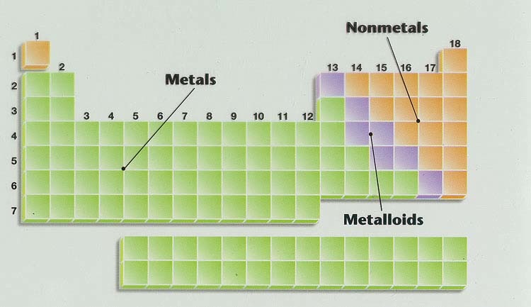

- Periodic Properties (use Table S)
Periodic properties are those properties that show a regular repeating decrease or increase in value as the atomic number increases. Periodic properties include

- atomic radius - the radius of an atom (Table S)
- ionization energy - the energy required to remove the most loosely held electron from an atom (Table S)
- electronegativity (electron affinity)- the tendency of an atom to attract electrons (Table S)
- metallic character - the tendency of an atom to lose electrons
- nonmetallic character - the tendency of an atom to gain electrons

PERIODIC TREND | ACROSS A PERIOD | DOWN A GROUP
atomic radius | decrease | increase
ionization energy | increase | decrease
electronegativity | increase | decrease
metallic character | decrease | increase
valence electrons | increase | remains the same
# occupied PEL’s | remains the same | increase
atomic number | increase by 1 | increase

TRENDS IN PERIODIC PROPERTIES ARE DUE TO…
- Number of principle energy levels (PEL’s or shells)
- Nuclear charge (number of protons and the attractive force of those protons)
- Shielding effect (number of PEL’s between the nucleus and valence shell that blocks the holding force of the nucleus)
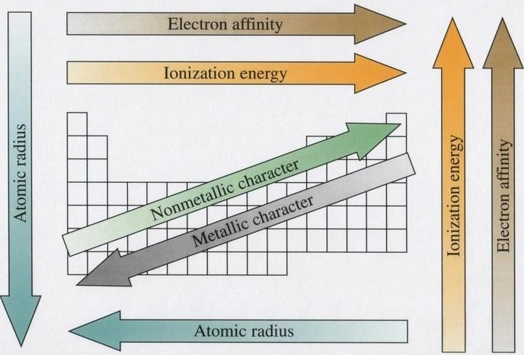

Questions
Organizing the Elements
Pg. 166
5.a)_____Metal_______ b)____Metaloid_____ c)_Nonmetal_______
d)_____Metal_______

6. ______B______

Classifying the Elements
Pg. 173
14. a)___Akaline earth____ b)_____Halogen_______
c)______Alkali metal______ d)___Akaline earth_______

17. _____________Cu, Cd, Au, Co_____________________________

Periodic Trends
Pg. 182
18. Increases down a group__________
Decreases across a period____________________

20. Decrease down a group
Increase across a period

21. Anions (-) have larger radii than their atoms
Cations (+) have smaller radii than their atoms

22. Decreases down a group
Increases across a period

Assessment
Pg. 186-187
29. Yes, they are in the same group and have the same # of valence electrons

34. ________He__________

38. a)_______Na_______ b)_____Sr______ c)_____Ge______

43. The ionic radius is smaller than its atomic radius

50. a) __C_ b)___La__ c)___Ne, P, Br___ d)___Bi__

53. Nonmetals = ionization energies increase from left to right across a period/
they are closer to having completely filled outer energy level

Complete the Following:
- How many rows are on the current periodic table? _________7_____________
- How many columns (groups) are on the current periodic table? ______18_______
- How is the periodic table arranged? ______________by Atomic #____________
- What are the two rows below the main body of the periodic table called? ___Lanthanide__________ and _____Actinide_______
- Where are the nonmetals located on the periodic table? _______________________Right of the staircase_______________________
- Where are the metals located on the periodic table?
______________Left of the staircase_______________________________
- Where are the metalloids located on the periodic table?
________________On the staircase________________________________
- Which groups contain transition metals? Group __3__through Group__12____
- Which group contains elements with completely filled p orbitals? ___18____
10. Which column contains elements whose electron configurations end with a d orbital? ___3-12_____

11. Where are the most active metals located on the periodic table?
_____Bottom left of periodic table____________
Where are the most active nonmetals located on the periodic table? __________Top right of periodic table________
- Which is the most active nonmetal on the periodic table? _____F_______
- a. What happens to the ATOMIC RADIUS as you move across a period
from left to right? __________Decreases____________
b. Why does this radius change? _________increasing atomic #_____
- a. What happens to the ATOMIC RADIUS as you move down a group from
top to bottom? _________Increases_________
b. Why does this change in radius occur? ______Adding energy levels___
- a. What happens to the ionization energy as you move across a period from
left to right? __________Increases__________________
b. Explain why? ___________outer e⁻ are closer to the nucleus__________
- a. What happens to the ionization energy as you move down a group from
top to bottom? _________Decreases_______________
b. Explain why? _________valence e⁻ are further from the nucleus______
- What are the names of the following groups?
- Group 1_______Alkali Metals____________________________
- Group 2 _______Alkaline Earth Metals________________________
- Groups 3-12 ______Transition Metals____________________
- Group 17 ______Halogens_______________________
- Group 18 ___________Noble Gases/ Inert Gases__________________
- Elements within a group have the same number of __Valence e⁻__
- Elements within a period have the same number of _Outer energy level__
- What are the “special” characteristics of transition elements?
- _____form colored ions in solution______________________________
- _____metals with multiple oxidation #s_______________________________
- _____they are filling their d sublevel________________________
- What happens to the metallic character as you go down a group? ___Increases_______
- What happens to metallic character as you go across a period? _____Decreases______
- The majority of the elements on the periodic table are (metals/nonmetals/metalloids) ____Metals____
- The majority of the elements on the periodic table are ( solids/liquids/gases) __Solids______
- Elements on the periodic table are organized according to their
____Atomic #______
- An element with properties of both metals and nonmetals is called_
Metalloid/ semimetal
- Why do group 18 elements have higher ionization energies and
NO electronegativity values? __________They have a full outer energy level_____

Putting it all together….
1 2 3 4 5 6 7 8 9 10 11 12 13 14 15 16 17 18
I
 | F |  |  |  |  |  |  |  |  |  |  |  |  |  | G | H
 |  |  |  |  |  |  |  |  |  |  |  |  | B |  |  |  | A
C |  |  |  |  |  |  |  | E |  |  |  | J

Place the letter from the periodic table above next to the description that best matches that element:

- an alkali metal __C_
- an inactive gas _A___
- a semimetal __B__
- a metal with more than one bonding possibility __E__
- an alkaline earth metal ___F_

- an active nonmetal__H or G__

- a metal with 3 valence electrons__J__
- a nonmetal with 1 valence e__I__

Pearson SuccessNet Online:
Chapter 6: Kinetic Art: Periodic Table Tour

